Coming soon to the Training Collective

June 21, 2025, 9-4pm, 4056 Dean Martin Drive, Las Vegas, NV

Applied Tactics phase I Workshop

CQB- Striking- Edged Weapon awareness training- Weapon protection & deployment strategies.

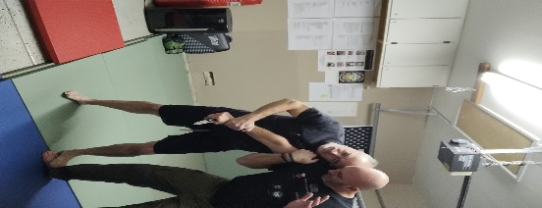

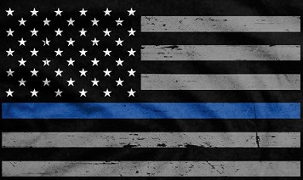

Sal Mascoli Marine Veteran/Trainer/Former LVMPD Officer/ DTI/martial artist/Owner of the Las Vegas Training Collective.

Jon Gentile/ Ret LVMPD Sgt/ DTI/ Trainer/ Instructor in several different martial arts disciplines. Primary subject in the documentary “Wrist Lock”

\*Target audience- Trainers, LEO’s retired and active, security operators, martial artist, and weapon carriers.

For more information visit us online or call Jon @702-506-2066 Sensibletrainingsolutions@yahoo.com or

Sal@ 702-277-7159. Registration opening soon!